# Retirement Finance Model Description

The Retirement Finance Model (RFM) uses Monte Carlo Simulation to test various financial strategies. Several key parameters are randomized, including lifespans, capital markets, inflation, consumption and allocation of retirement savings to annuities, equities, bonds and cash.

Retirees are typically concerned about spending and many have a bequest motive. RFM, however, measures success primarily as the maintenance of a household's desired standard of living throughout their full lifetimes. A "failed scenario" is any simulated scenario that funds less than 100% of the lifetimes of all household members.

RFM calculates a percentage of scenarios that fail, which is the primary point of comparison to multiple sets of simulations. RFM also provides a number of summary analyses of these failed scenarios. These include failed scenarios by consumption level, by equity allocation, by annuity allocation and by Social Security claiming ages, for example.

These analyses allow the user, for example, to note that certain equity allocations result in a greater failure level and to remove those allocations from a subsequent run to compare results.

# Key Input Factors

## Initial parameters

* Number of scenarios to run in this simulation (10,000, for example)
* Wife's current age
* Husband current age

## Social Security parameters

* Age wife will claim Social
* Age husband will claim Social - Security benefits at 62, FRA and 66

## Portfolio parameters

* Initial portfolio balance
* Equity allocation

## Market and inflation parameters

* Annual average rate of stock returns
* Inflation rate annual standard deviation
* Risk-free real return rate
* Equity risk premium
* Standard deviation of annual market returns

## Annuity parameters

* Age of annuitant when payments will begin
* Annual payment before any deaths
* Annuity is inflation protected owns Annuity
* Payout of fixed annuity
* Percent annuity survivor benefit

## Spending parameters

* Expected spending year one of retirement
* % expense decline after death of first spouse
* % change in annual expenses throughout retirement

## HECM line of credit and home equity parameters

* Current market value of primary residence
* Annual real rate of residential housing appreciation
* Mean long term return for 1-yr Libor
* Standard deviation for 1-yr Libor
* HECM line of credit's initial credit limit
* HECM line of credit's initial - HECM line of credit's maximum lifetime interest rate
* HECM line of credit's margin percent
* HECM line of credit's Monthly Insurance Premium percentage

# Randomized Variables

The following variables are randomized by RFM:

* Stochastic lifetimes are generated using current mortality tables
* Stock market returns are randomized assuming a normal distribution with historical market returns averages and standard deviations
* Inflation rates are randomized assuming a normal distribution with historical annual inflation rate averages and standard deviations
* Risk-free rates are randomized assuming a normal distribution with historical 1-year Libor rate averages and standard deviations

The following variables are uniformly randomized:

* Equity Allocation from 0% to 100% in steps of 10%
* Annuity Allocation from 0% to 100% in steps of 10%
* Annual consumption within a user-specified range
* Social Security-claiming ages
* Annual average rate of inflation
* Inflation rate annual standard deviation
* Risk-free real return rate
* Equity risk premium
* Standard deviation of annual market returns

## Annuity parameters

* Age of annuitant when payments will begin
* Annual payment before any deaths
* Annuity is inflation protected owns Annuity
* Payout of fixed annuity
* Percent annuity survivor benefit

## Spending parameters

* Expected spending year one of retirement
* % expense decline after death of first spouse
* % change in annual expenses throughout retirement

## HECM line of credit and home equity parameters

* Current market value of primary residence
* Annual real rate of residential housing appreciation
* Mean long term return for 1-yr Libor
* Standard deviation for 1-yr Libor
* HECM line of credit's initial credit limit
* HECM line of credit's initial - HECM line of credit's maximum lifetime interest rate
* HECM line of credit's margin percent
* HECM line of credit's Monthly Insurance Premium percentage

# Randomized Variables

The following variables are randomized by RFM:

* Stochastic lifetimes are generated using current mortality tables
* Stock market returns are randomized assuming a normal distribution with historical market returns averages and standard deviations
* Inflation rates are randomized assuming a normal distribution with historical annual inflation rate averages and standard deviations
* Risk-free rates are randomized assuming a normal distribution with historical 1-year Libor rate averages and standard deviations

The following variables are uniformly randomized:

* Equity Allocation from 0% to 100% in steps of 10%
* Annuity Allocation from 0% to 100% in steps of 10%
* Annual consumption within a user-specified range
* Social Security-claiming ages

# Spending Model

RFM models scenarios as follows:

1. A state table is created indicating the number of household members alive for a given year of retirement.
2. Simulated annual spending for this year is deducted from the guaranteed income sources including Social Security benefits, pension benefits and annuities.
3. Additional spending, if required, is deducted from a savings portfolio, if available.
4. Once savings are depleted, spending will be deducted from a reverse mortgage, if available.
5. Since most retirees will have some level of Social Security benefits there will always be some level of consumption. If consumption does not meet spending requirements for this scenario, the scenario will be flagged as underfunded, as will the year of this scenario.
6. This process continues until the scenario reaches the state in which there are no surviving household members.
7. For completely-funded scenarios, terminal net worth and terminal portfolio values are recorded.

# To Be Completed

The following features are planned:

* An option for allocation of savings to deferred income
* Verification of adequate cash flow

# Model Outputs

A sample report generated by RFM is included in Appendix B.

# Appendix A. Variable Values

|  |  |  |  |
| --- | --- | --- | --- |
| Variable | Values | Model Distribution | Defaults |
| Number of scenarios to run in this simulation | 100,000 but limited only by computer capacity | Scalar | 10,000 |
| Wife's current age | 62 - 120 | Scalar |  |
| Husband current age | 62 - 120 | Scalar |  |
| Age wife will claim Social Security benefits | 62, Full Retirement Age, or 70 | Scalar |  |
| Age husband will claim Social Security benefits | 62, Full Retirement Age, or 70 | Scalar |  |
| Initial portfolio balance | Unlimited | Scalar |  |
| Equity allocation % of savings | Range from 0% to 100% | Uniform | 0% to 100% steps 10% |
| Annual average rate of inflation | 0% or more | Normal | 2% |
| Inflation rate annual standard deviation | 0% or more | Normal | 1% |
| Risk-free real return rate | 0% or more | Normal | 1% |
| Equity risk premium | 0% or more | Normal | 4.25% |
| Standard deviation of annual market returns | 0% or more | Normal | 12% |
| Age of annuitant when payments will begin | 1. to 120 | Scalar |  |
| Annual payment before any deaths | >$0 | Scalar |  |
| Annuity is inflation | TRUE/FALSE | Scalar | FALSE |
| Payout of fixed annuity | >=$0 | Scalar |  |
| Percent annuity survivor benefit | 0% to 100% | Scalar |  |
| Expected spending year one of retirement | >0 | Scalar |  |
| % expense decline after death of first spouse | 0% to 100% | Scalar | 63% |
| % change in annual expenses throughout retirement | -2% to 2% | Scalar | 0% |
| Current market value of primary residence | >0 | Scalar |  |
| Annual real rate of residential housing appreciation | >=0% | Scalar | 0% |
| Mean long term return for 1-yr Libor | >=0% | Normal | 2% |
| Standard deviation for 1-yr Libor | >=0% | Normal | 1% |
| HECM line of credit's initial credit limit | >=0 | Scalar |  |
| HECM line of credit's maximum lifetime interest rate | >=0 | Scalar |  |
| HECM line of credit's margin percent | >=0% | Scalar |  |
| HECM line of credit's Monthly Insurance Premium percentage | >=0% | Scalar |  |
| Stochastic lifetimes | To age 120 | Based on mortality tables |  |
| Expected stock market returns | >=0% | Normal | 5% |
| Inflation rates | >=0% | Normal | 1% |
| Risk-free rates | >=0% | Normal, 1-yr Libor |  |
| Annuity Allocation % of savings | 0% to 100% steps of 10% | Vector | 0% to 100% steps of 10% |
| Annual consumption range | >=$0 | Vector |  |

# Appendix B. Sample Model Output

Retirement Finance Simulation Model

# Client: John and Jill Smith

Tue Dec 12 14:08:34 2017

Assumptions for the simulations are as follows:

* Run 10,000 scenarios.
* Demographic data
  + Husband's current age is 65.
  + Wife's current age is 67.
* Social Security data
  + Husband has the highest Social Security benefit is TRUE.
  + Expected Social Security benefit for lower earner is $ 17,580.
  + Expected SS benefit for higher earner is $ 36,444.
* Portfolio parameters
  + Initial portfolio balance before annuity purchase is $ 3,940,000.
  + Equity allocations randomized from 0% to 100%.
* Market and inflation parameters
  + Annual average rate of inflation is 2%.
  + Inflation rate annual standard deviation is 1%.
  + Risk-free real return rate is 1%.
  + Equity risk premium is 4.25%.
  + Standard deviation of annual market returns is 12%.
* Annuity parameters
  + Age of annuitant when payments will begin is 66.
  + Quote for annual payment before any deaths is $ 9,600.
  + Annuity is inflation-protected is FALSE.
  + Husband owns Annuity is TRUE.
  + Percent of benefit that goes to survivor is 50%.
  + SPIA payout rate is 5.36%. $ Annuity allocation as percent of initial portfolio randomized from 0% to 40%.
* Spending parameters
  + Expected spending year one of retirement randomized from $ 216,000 to $ 240,000.
  + Percent expense decline after death of first spouse is 63%.
  + Expenses typically decline 0% annually throughout retirement.
* HECM Line of Credit
  + Home apprecation rate is 0% annually.
  + Initial HECM Line of Credit available is $ 0
  + Initial Reverse Mortgage Balance is $ 0
  + Home Market Value (no real annual growth assumed) is $ 1,200,000
  + Mean long term return for 1-yr Libor= 2% with standard deviation= 1%
  + HECM line of credit's maximum lifetime interest rate cap 10.34%
  + HECM line of credit's margin added to Libor Index for variable rate loan 3%
  + HECM line of credit's Monthly Insurance Premium percentage 1.25%

PARAMETER SIMULATIONS

Life expectancies for husband and wife are plotted below.

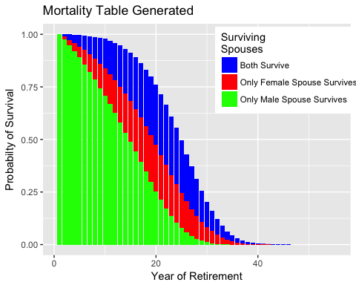

## .Primitive("return")

The following annual market returns were simulated.

## Warning: Removed 56 rows containing non-finite values (stat_bin).

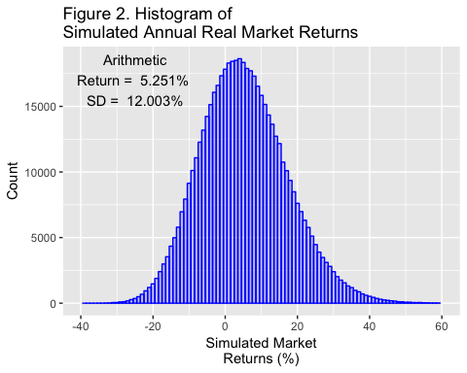

Arithmetic Mean of Simulated Annual Returns = 5.251%.

Standard Deviation of Simulated Annual Returns = 12.003%.

The following simulated annual inflation rate were simulated:

## Warning: Removed 36 rows containing non-finite values (stat_bin).

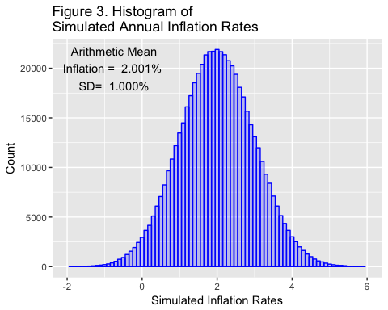 * Arithmetic Mean of Simulated Inflation Rates = 2.001%.

* Standard Deviation of Simulated Annual Inflation Rates = 1%.

The graphs that follow are intended to show the range of inputs used by the simulation model (for example, the range of spending tested) and the distributions of the input parameters (for example, life expectancy follows a Gompertz distribution, while spending parameters are randomized with a uniform distribution.)

The following chart shows the number of scenarios simulated at each level of annuity allocation. The *x*-axis shows the range of annuity allocations simulated.

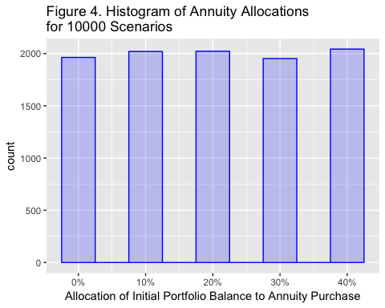

The following chart shows the number of scenarios simulated at each level of equity allocation. The *x*-axis shows the range of equity allocations simulated.

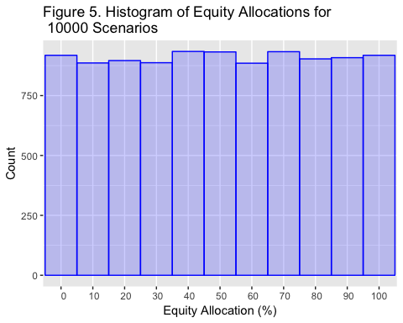 # Results of Simulations

* Statistics For Underfunded Scenarios
* 391 scenarios with unmet spending or 3.91%
* Some failed scenarios were almost completely funded, while some funded scenarios were just barely funded. These scenarios fall within the margin of error.
* Percent of scenarios that funded less than 95% of years 3.38%
* Percent of scenarios with 95% to 105% of years funded
* Percent of scenarios with more than 105% funding
* Number of years with unmet spending 2041
* Mean years with unmet spending when spending not met 5
* Depleted portfolios 3.91 %
* Scenarios depleting HECM Line of Credit 0 or 0%

The previous charts showed the distribution and ranges of key randomized inputs to the simulation model including spending, equity allocation, annuity allocation and stochastic life expectancies. The following charts provide a summary of the simulation model's output for those scenarios and years that were underfunded in the simulation.

Following is a histogram showing spending amounts (and the range of spending along the *x*- axis) for the first year of each retirement scenario.

This histogram shows the cumulative ratio of underfunded simulated years by the amount of spending for the first year of retirement. The right-most column, for example, shows that 100% of 391 unfunded years had spending in the first year of retirement of $ 240,000 or less. The column to its left shows that about 80% of all 391 unfunded years had spending in the first year of retirement of $ 237,600 or less.

About half of the 391 underfunded years in this simulation could have been funded by spending less than $ 232,800 from the beginning of retirement.

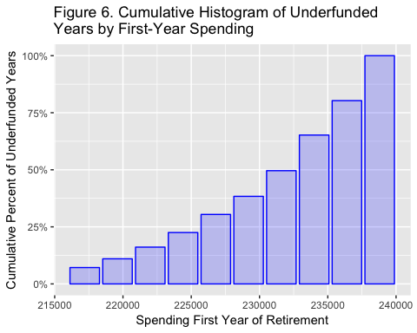

Following is a histogram showing the equity allocation for underfunded scenarios (an underfunded scenario had at least one underfunded year).

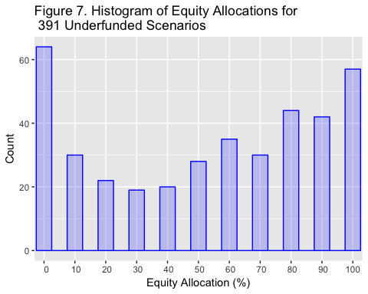

Following is a histogram showing the equity allocation for all underfunded *years*.

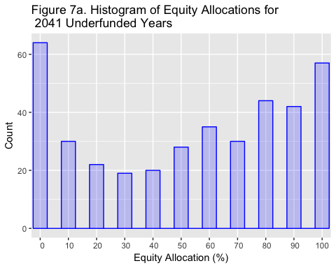

Following is a histogram of 99 %-ile terminal net worth (portfolio value plus home equity at death of the second spouse). The largest 1% of terminal net worth values are excluded because they are highly unlikely and distort the graph.

## `stat_bin()` using `bins = 30`. Pick better value with `binwidth`.

## Warning: Removed 500 rows containing non-finite values (stat_bin).

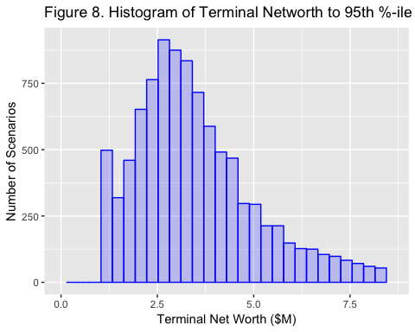

* Median Terminal Net Worth = $ 3,292,183.
* Mean Terminal Net Worth = $ 3,980,048.
* About two-thirds of Terminal Net Worth values fell between $ 1,072,589 and $ 6,887,507.
* About 95% of terminal portfolio values fell between $ 0 and $ 9,794,966.

The following graph shows the percent of years that were funded for the 391 *scenarios* that were underfunded, i.e., those scenarios with less than 100% funded years. Leftmost columns show the number of scenarios that failed early in retirement. Rightmost columns show the number of scenarios that were nearly completely funded.

Rightmost columns may fall within the margin of error and possibly should be considered successful scenarios. In this simulation, 53 or 13.5549872% of underfunded scenarios were at least 95% funded.

## Warning: Removed 500 rows containing non-finite values (stat_bin).

## Warning: Removed 7 rows containing missing values (geom_bar).

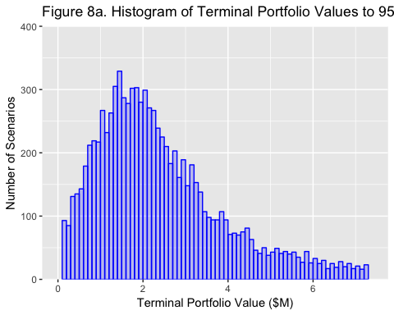

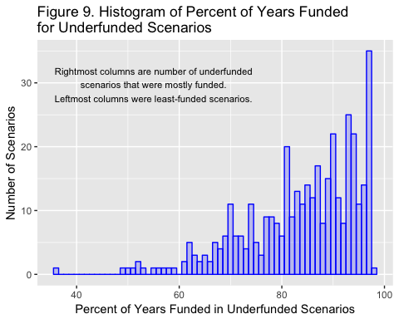 The following graph shows the number of years of retirement for which spending demand (consumption) was *not* met.

The following chart shows terminal home equity for all scenarios. If a HECM reverse mortgage is available, home equity can become negative but this is non-recourse debt and will not lower the household's terminal net worth.

## `stat_bin()` using `bins = 30`. Pick better value with `binwidth`.

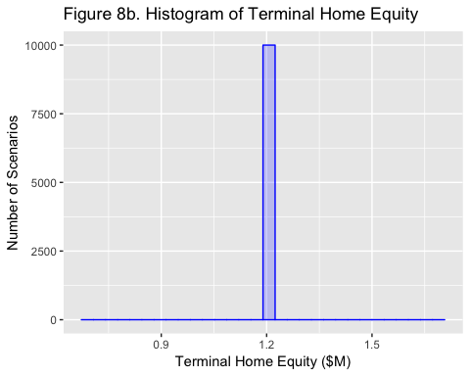

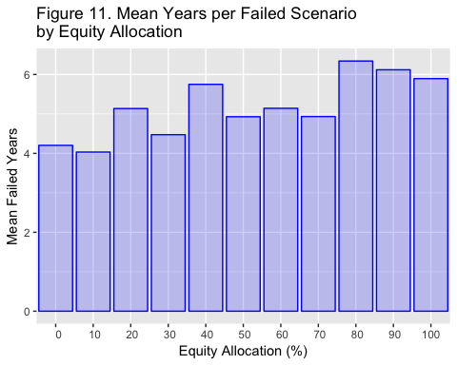 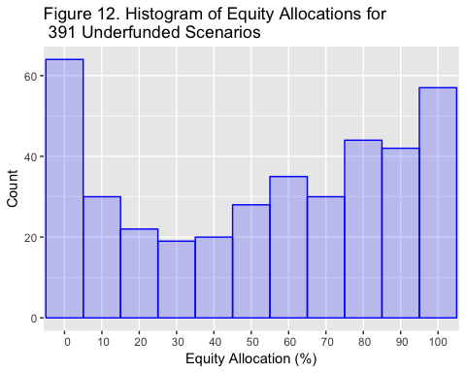

The following charts summarize a single, user-selected scenario. The black line shows consumption demanded. The colored areas indicate the source for funding that consumption. Underfunded years will show that funding sources did not achiev demanded consumption.

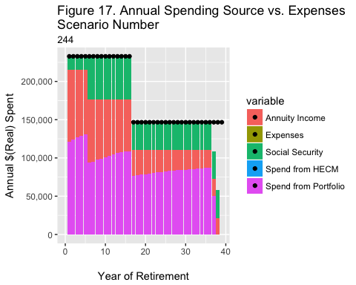

## Warning: Removed 30 rows containing missing values (position_stack).

